Karan Kumar S

210519104045

# Assignment question::

Using PIR sensor and tmp36(Temperature sensor), piezo alarm, please create a circuit with Arduino Uno with below functionalities.

1. Alarm should give one sound when there is a motion near PIR sensor

2. Alarm should sound with different sound when the temperature is above 60 degrees.

## Arduino code :

float temp;

int Buzz=A2;

int sensor=12;

int transistor=2;

void setup()

{

Serial.begin(9600);

pinMode(2,INPUT);

pinMode(12,OUTPUT);

Serial.println("waiting for motion");

}

void loop()

{

double data=analogRead(A2);

double n=data/1024;

double vout=n*5;

double off=vout-0.5;

double temperature=off*100;

Serial.print("Temperature data: ");

Serial.println(temperature);

if(temp>60)

{

digitalWrite(Buzz,HIGH);

Serial.println("temperature detected");

tone(12,100);

delay(1000);

tone(12,200);

delay(1000);

}

int val = digitalRead(2);

if(val ==HIGH)

{

digitalWrite(transistor, HIGH);

Serial.println("Motion Detected");

tone(12,100); //pin number, frequency, delay(optional)

delay(1000);

tone(12,200);

delay(1000);

}

if(temp <= 60)

{

digitalWrite(Buzz,LOW);

Serial.println("No temperature detected");

noTone(12);

delay(500);

}

if(val == LOW)

{

digitalWrite(transistor, LOW);

Serial.println("NO Motion");

noTone(12);

delay(500);

}

delay(1000);

}

### SCREENSHOT :

Screenshot 1::

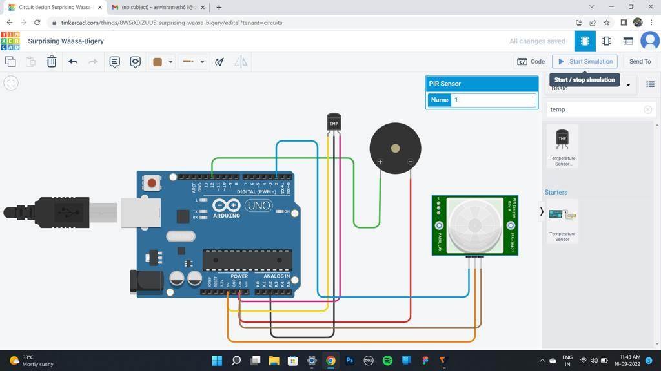

Screenshot 2 ::

